2012 Dirty Digs Newsletter
By Mari Pritchard Parker

The Milford Archaeological Research Institute (MARI) summer field season again consisted of two sessions, in spite of the continuing California statewide budget cuts. The first session which ran from June 20-30th was again through Fresno City College (FCC) - and the second session (July 2-13th) was again through Pasadena City College (PCC). As last year the state of the economy did impact the overall student enrollment, but with the help of small scholarships and equipment loans, we managed to provide yet another successful summer program.

The focus for the first session was on the students learning the skills necessary for excavations, while session 2 focused on pedestrian surveying techniques. Students were grouped into crews with a leader (a staff member) that monitored and advised on the performance of first time field students and mentored them along the way. The workload was shared, so everyone had an opportunity to experience the multiple activities that jobs in archaeology involve.

The first day started off with a walk over of the site and instruction on camp basics. This gave instructors, staff, and students a couple of hours to get down to the basics while the students mingled and adjusted to the 5,000 foot elevation before their first field trip. The rest of the days the students where engaged in the hard physical work and hands-on priceless experience. Lab work and journal keeping made the archaeological process of record keeping, artifact collecting, and data entry real, to the finest details.

Not only did the students learn to work within groups and within units, they also were exposed to Great Basin history and culture. Mr. Gardiner Dalley graciously joined us and shared his expertise and experience from numerous years in the field. Thanks to Mr. Steve Stacey's instruction, the students learned basic surveying techniques. Steve worked one-on-one with students, showing them the techniques of mapping and gridding an archaeological site, which entailed transit surveying, field note-taking, and reading of the stadia rods. This year Dr. Jeanne Day Binning again conducted flint knapping demonstrations and instruction for both classes. Students received training on varied and multiple skill levels and Dr. Binning provided the students with resources and an introduction to the need for debitage analysis. Students as always received first-rate theory and practical training in flint knapping and lithic technology.

The schedules allowed students to plan in advance for activities and their daily chores. The staff and group leaders made sure that the students’ safety came first, and that the daily unit chores were completed which ensured a clean public area.

Additional activities during the first session included a visit to the Fremont Museum, Southern Utah University’s Archaeological Repository where Ms. Barbara Frank gave us a delightful tour of the facility, the Parowan Gap petroglyphs, the Mineral Mountains obsidian quarries, Lehman Caves (Great Basin National Park) with a special stop at some of the parks rock art with Ms. Eva Jensen, and the Frisco ghost town - all the while working on their units, excavating, screening, and record keeping.

During the second session, students finished the excavations, back-filled their units, and took a trip to the Topaz Mountain Internment Camp in Delta. Ms. Jane Beckwith gave a talk at the camp, which provided a wealth of information for the students. We were again able to work with Nate Thomas of the Cedar City’s Bureau of Land Management (BLM). Students and staff worked side-by-side for three days near the Minersville reservoir where they practiced pedestrian survey in search of artifacts (e.g., pottery). Students had the unique experience of working with professional archaeologists in a natural environment that included a variety of desert plant and animal species.
Thanks again for all the help and support of the staff and guest lecturers, without it I would not be able to provide such a wonderful experience for the students.

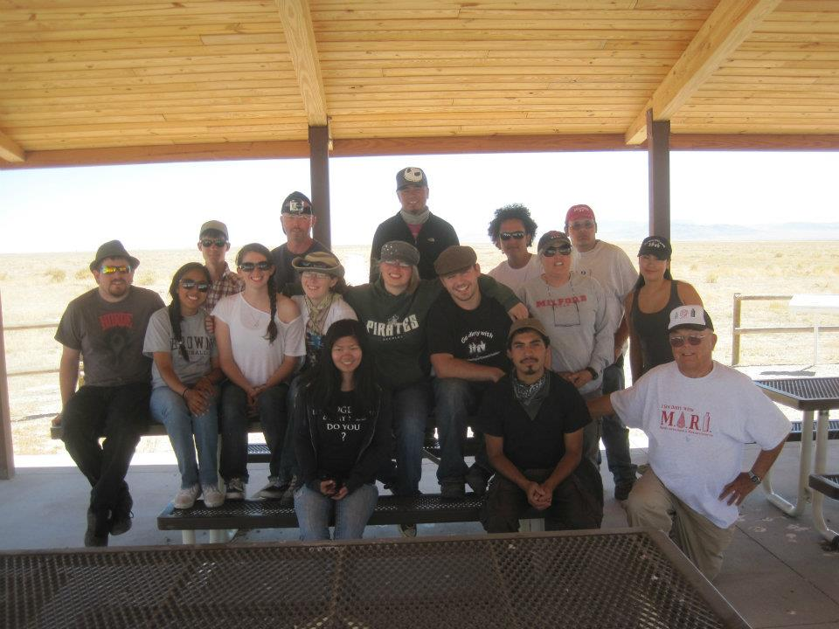
Summer Field School 2012
July 2nd- July 13th
by Irving Orozco

The second session of the Milford Archaeological Research Institute, taught by Mari Pritchard Parker, near the small town of Milford, Utah which started on the 2nd of July, a couple of days after the end of the first session, which ended on June 30th. With a few returning students coming back from the first session, and a few newcomers whom, at the time, have yet to get their hands dirty out on the field. So much was planned for this session, some stuff was review of the previous session, like flint knapping, and the other basics to excavation, but the difference with the second session as well as the addition of the field surveying out in the mineral mountains not far from the site, and a ceramics workshop with Eva Jensen of the Great Basin National Park. The experience was great, team effort in finishing the excavation projects, and a good amount of sightseeing, traveling around southern Utah visiting different sites made the second session more of an adventure than just school work. To their surprise, the second session was filled with a lot of interesting environmental activities that were not expected, it brought the first rain, it brought lightning storms, and it brought fires.
4th of July came, bringing with it the annual parade through the main street of the town. The students participated in the festivities, which the town doesn’t mind since they know the field school is always held each summer, it is common knowledge among the people of the town that every year there are students digging out at a site not too far from there. It sometimes even draws their attention; some even go check out the site, just to take a look at the whole operation. Sadly, the day following the festivities, the students were greeted by rain. It was so strange that one of the students thought that perhaps the water fight during the parade was probably a kind of rain calling ritual that drew the clouds there, convincing them that the town’s people did it with the intention of bringing in the clouds. Ritual or not, the weather ended up putting things to a halt for a whole day due to the risk of getting struck by lightning. But the day was not wasted; some went on a trip to the Fremont museum, which the returning students already went to, and others stayed at the site to wait for the afternoon lesson on flint knapping.
Work continued the next morning of course and that is how it was for the rest of the session, some continuing their work on excavation units that have already been being worked on, others starting new units, continuing the work that was left off from the previous session. The students also visited other sites like the Topaz Mountain internment camp and Pavant Butte, which many students enjoyed. Now, unlike a regular classroom, the learning experience was a little different because it is a little more hands on, you learn out in the field. After all, archaeology is best experienced at the field and the field school provided that environment to learn more on the techniques, and gain experience in the field of archaeology. Yes, it is lots of hard work but in the end the valuable lessons learned, the appreciation of all the hard work that is put into the excavation, is probably the best experience anyone can get from a field school. Students were able to uncover a possible adobe wall, which seemed to go through several units at the excavation site. And the natural environmental events that occurred during this session just made it all even more interesting.
Experiencing nature first hand is also one of the best feelings that anyone could have, especially those who would just simply want to have a completely different learning environment, one that is away from a classroom setting, and out in the sun, getting their hands dirty and actually trying to find something, which by the way doesn’t always happen. Lightning storms are a common environmental phenomenon that occurs in the area, one that can be potentially dangerous and potentially beautiful. It was a display that did not fail to present itself on the final days of the field school, starting a fire in the mountains south of the camp, creating both a scary yet beautiful sight as the lightning sparked all around. Yes, the field school is something else. Someone could sit here and talk all about how good it was, but the best way to know for sure is to experience it for yourself.

