Milford Archeological Research Institute 2013
Newsletter

The 2013 Milford Archaeological Research Institute's (MARI) excavation in Milford Utah, lead by professor Mari Pritchard Parker though Pasadena City College, brought together students from all over the state of California. The two-week stay in Milford was filled with excavations, archaeology lab work, field-trips across Utah and Nevada, potlucks and parades.
This year's students came from various Colleges and Universities, which included Pasadena City College (PCC), Fresno City College (FCC), California State University, Northridge (CSUN), California State University Los Angeles (CSULA) and the University of California, Los Angeles (UCLA). Coming from different education backgrounds allowed the students to compare and share their experiences with archaeology, while learning from each other through both formal and informal instruction. Students, who participated in last year’s excavations, had the opportunity to become unit leaders this year, allowing them to expand their experience in a leadership role during the excavation. Teaching assistants Julie Lau and Victor Vazquez were on hand again this year to assist students with excavating, lab work, and general questions. We were also privileged to be visited by PCC professors Dr. Derek Milne and Andrea Murray and California State University Chico graduate student Aimee Van Havermaat. The Milford Summer Reading Program (7-12 year olds group) also came by for a tour of the site, to get a hands-on view of the "dig" which fit right in with this years topic "digging".
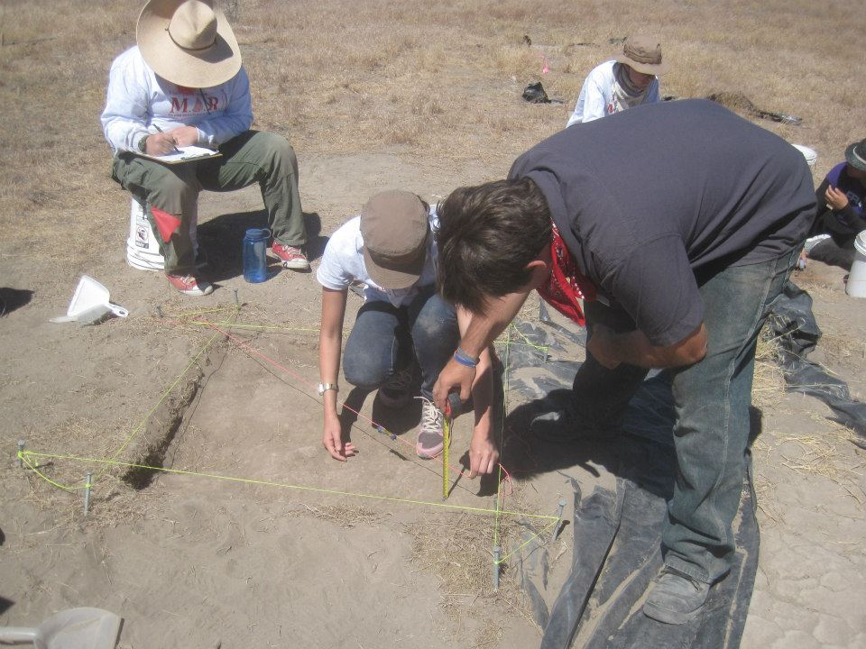
Despite the 100 F plus degree heat, the crews worked hard excavating the possible adobe wall structures identified last year on the east mound. Waking up early in the morning, the three person crews dug 1x1 meter units, investigating the adobe bricks. While the function of the adobe was inconclusive, the crews were able to make progress that will be continued next season. When students were not excavating, they spent time with surveyor Steve Stacey, who guided students through the mapping, grid layout and surveying of the site.
Aside from excavation, the students spent much of their time on field trips, exploring some of the well-known sites in the area. One of the favorites amongst students was Lehman Caves in the Great Basin National Park, which offered a cool respite from the hot day. During our private tour, students learned about stalactite and stalagmite formations, along with the other unique formations in the cave and historic use of the area. For many, this was their first caving experience. Close to the caves was Baker Village Fremont Indian Archeological Site, which was excavated between the years of 1991 to 1994. Visiting the site, allowed students to visualize the adobe wall structures of the Fremont Culture. During the walk over of the site students identified a few surface artifacts, such as a possible metate, corrugated and greyware ceramics, both plain and painted. Like good archaeologists, the students photographed the objects as a memento, and left the artifacts where they were found for future researchers.
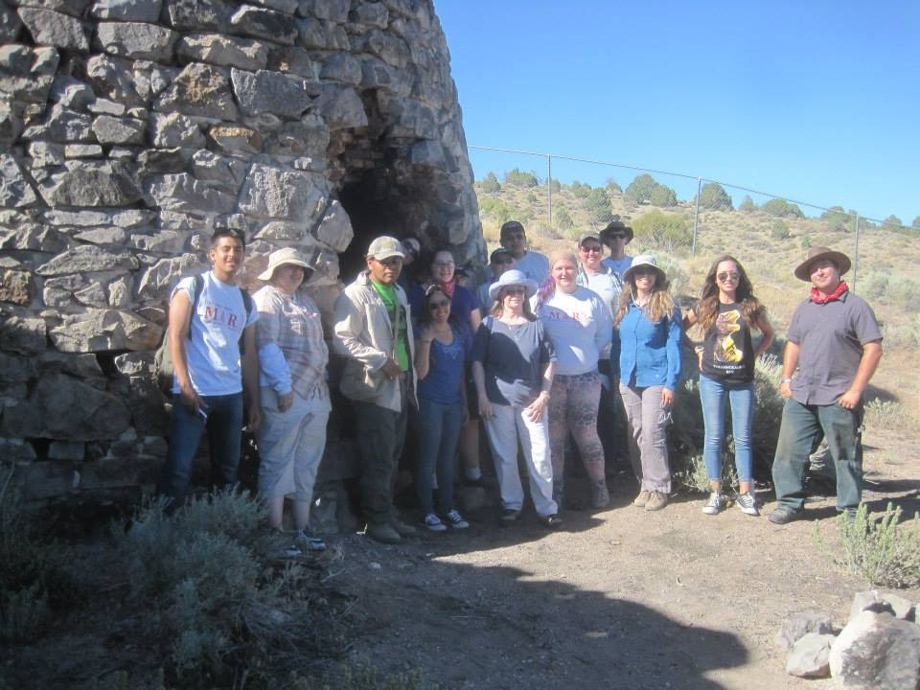
A field-trip to the ghost towns of Frisco and Newhouse was led by Dr. Paige Peyton, where students walked amongst the artifacts still strewn across the ground and explored the foundations of the abandoned buildings. Evidence of looter's holes were present at the site, reminding us all that looting continues to be a threat to our archaeological heritage. The visit also included a trip to the five beehive shaped kilns, where the group stopped for a picture, while appreciating the massive structures that were used for firing charcoal.
Other field-trips this season included a visit to the Fremont State Park Museum, Cedar Breaks National Monument, Parowan Gap petroglyph site and Southern Utah University's (SUU) curation facility, where the curator Barbara Frank was gracious enough again to allow students to peruse the archives. By allowing the students to pick up and touch various artifacts, they were able to obtain a sense of both the Fremont and Anasazi material culture. This hands-on experience not only gave students a more accurate picture of the artifacts we were looking for during excavation, but also allowed students to understand the weight and feel that each artifact has, an experience that is not fulfilled through a traditional museum visit.
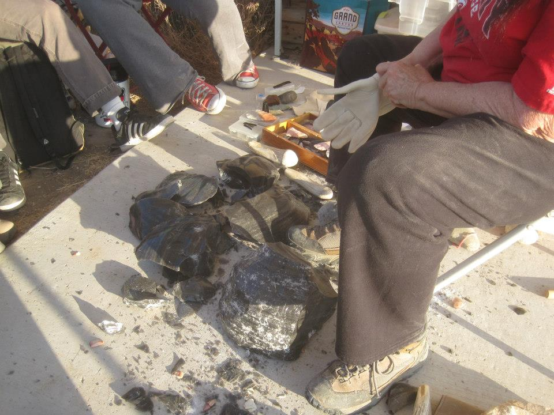
Dr. Jeanne Day Binning demonstrated flintknapping again this year, allowing the students a taste of experimental archaeology. As part of this experience a visit to the Pearl Queen perlite mine allowed students to collect their own obsidian materials, by hiking up the side of the mountain. During Dr. Binning’s demonstrations, students learned basic percussion and pressure flaking techniques. At the beginning of instruction, the task seemed insurmountable, however students quickly caught on, learning the proper grinding and percussion techniques in order to break off a flake.
The season would not be complete without participating in the Annual Milford Fourth of July parade, which was a wet one for both students and instructors alike. This year’s water fight rivals were Milford’s little league team who were armed with a trailer bed filled with water. Playful water fighting was exchanged between the two parade groups, with friendly fire being sustained by both. Candy and smiles were also given out to the kids along the route. The parade offered the MARI students and faculty contact with the community, while cooling down from the hot Utah day. This year's Fourth of July concluded with a viewing of Milford's firework show.
The season ended with the students' annual tradition of throwing their old shoes into the shoe tree, leaving a piece of them at Mariville - our home for the season. Throughout the two weeks students bonded and created close friendships, while learning about archaeological sciences and the Fremont Prehistoric Culture. While the excavation is over for this season, the memories and knowledge will last a lifetime. No doubt, many students will return next year to Milford, to once again explore the site, expand their archaeological knowledge, and share in camaraderie.

